
School of Informatics & IT – Malware Analysis Centre

Cover Page

Issue Tracker and Management Solution

Link to download the Codes and Glassfish server (if the other links not working):
https://1drv.ms/u/s!ArtU02He1D28go4W0eYwh6pm5k_Z1A?e=4nUv21

Azure DevOps Repository Link: https://dev.azure.com/1906438E/issue-tracker/_git/issue-tracker

Done By: Samuel Chan, Jaibun Thana and Toh Yun Zhen

Copyright Temasek Polytechnic - Malware Analysis Centre 2021/2022.
For internal circulation only.

Table of Contents

Cover Page 1
Table of Contents 2
File / Folder Structure 3
Setting Up the Environment 6
Features / Capabilities 9
Future Enhancement 10

File / Folder Structure

WAR Module

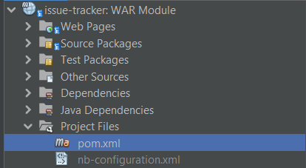 | pom.xml is included in both the war and ejb module  Used to define the project, configure plugins, and declare dependencies for Maven

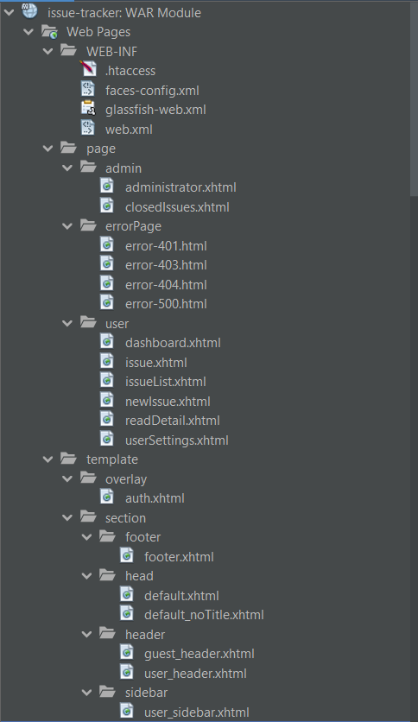  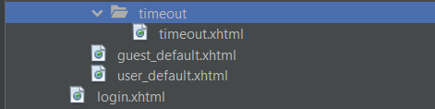  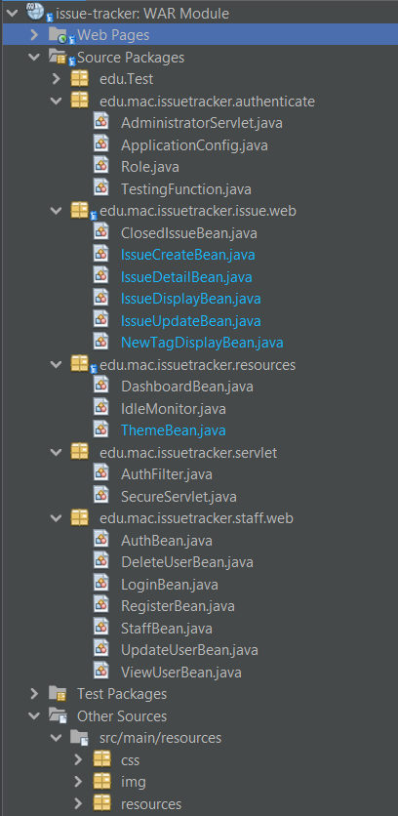 | Page (src/main/webapp/page): divided pages for different access control  Template (src/main/webapp/template): different sections divided on the webpage  Source Packages (src/main/java): backing beans to manage the front end of the website  src/main/resources: insert custom css values, images such as icons for the website, and variable values for the xhtml files

EJB Modules (Issue, Staff, IssueExt)

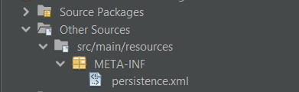 | There is an persistence.xml in every ejb module to configure the particular JPA persistence unit

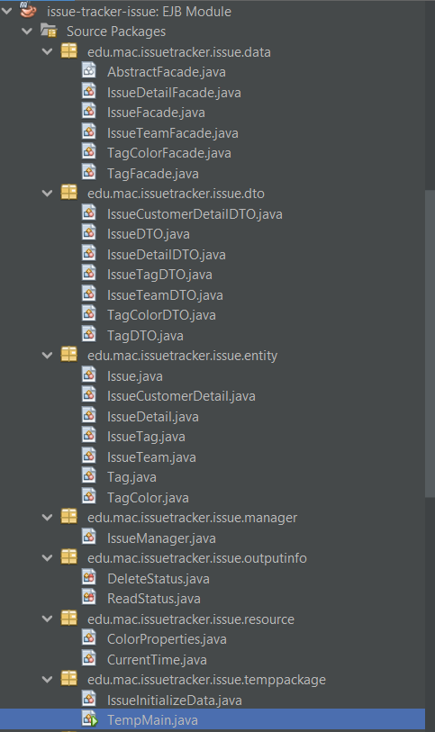  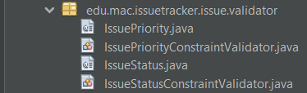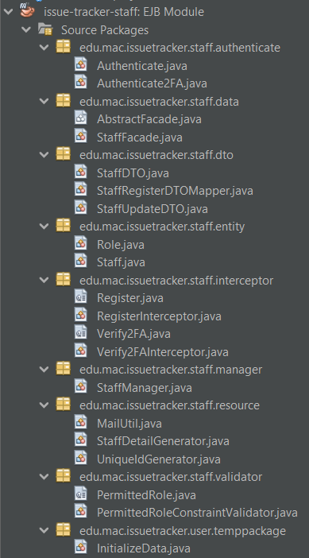  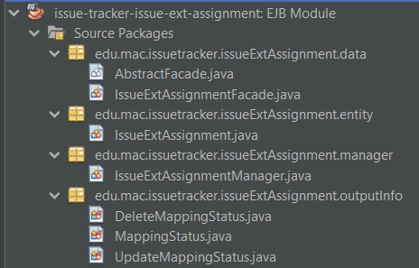 | .data: Database operation. E.g. CRUD  .dto: define data transfer object  .entity: Define POJO, and database properties  .manager: Contains business logic for other modules (e.g. web) to use.  .outputinfo: Enum for returning function status  .resource: Functions for manager to use  .temppackage: Used for testing. Not for deployment. (E.g. initialise data)  .validator: Custom Bean Validators used by other functions  .interceptor: Store interceptor used by other functions

Setting Up the Environment

 | Resources used
1 | Apache Netbeans 12.5 (IDE, version 12.5 and above)  https://netbeans.apache.org/download/nb125/nb125.html
2 | Glassfish 6.1 (Jakarta EE server/environment)  https://www.eclipse.org/downloads/download.php?file=/ee4j/glassfish/glassfish-6.1.0.zip
3 | JDK 11.0.13  https://www.oracle.com/java/technologies/javase/jdk11-archive-downloads.html
4 | MySQL Server 8.0.28 (Database server)  https://dev.mysql.com/downloads/mysql/
5 | PrimeFaces and PrimeFlex (GUI framework)  https://www.primefaces.org/showcase/index.xhtml?jfwid=3d207  https://www.primefaces.org/primeflex/

 | Steps to run the website for the first time
1 | Start Glassfish server
2 | Go to localhost:4848
3 | Create the relevant JDBC connection pool  (StaffPool, IssuePool and IssueExtAssignment)  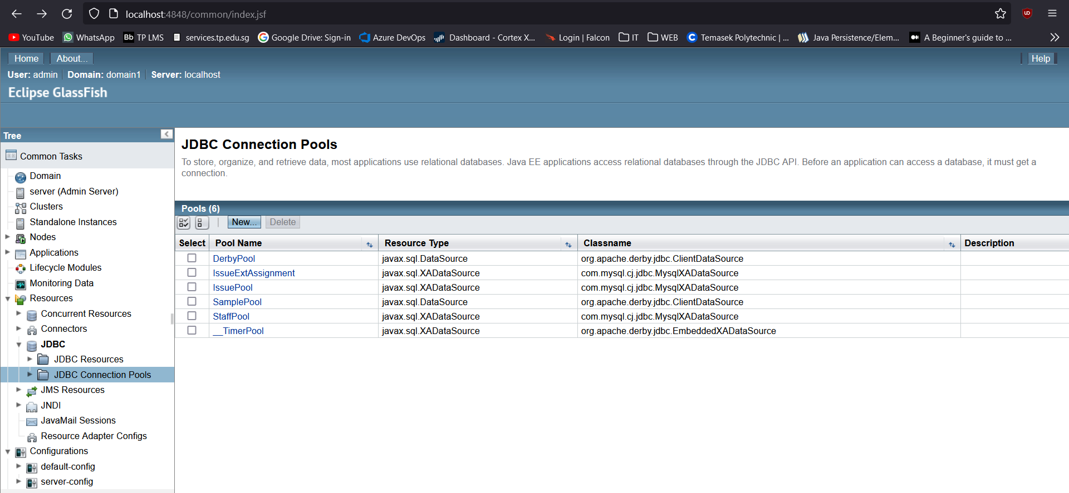
4 | Set the properties for each pool in additional properties  (user and password of the database server, and the url jdbc:mysql://localhost:3306/database-name?autoReconnect=true&useSSL=false)  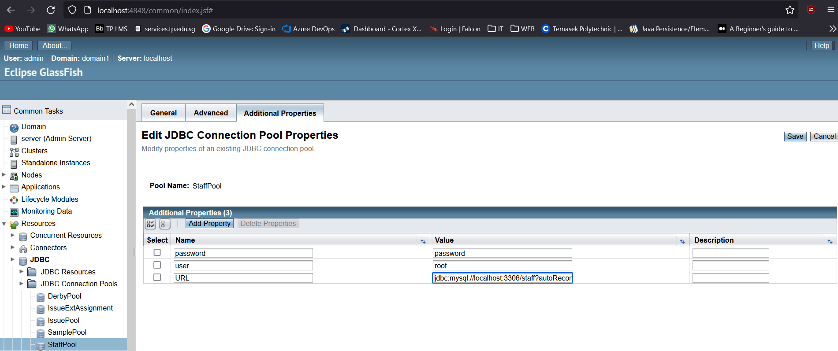
5 | Create the relevant JDBC Resources  (jdbc/StaffPool, jdbc/IssuePool, jdbc/IssueExtAssignmentPool)  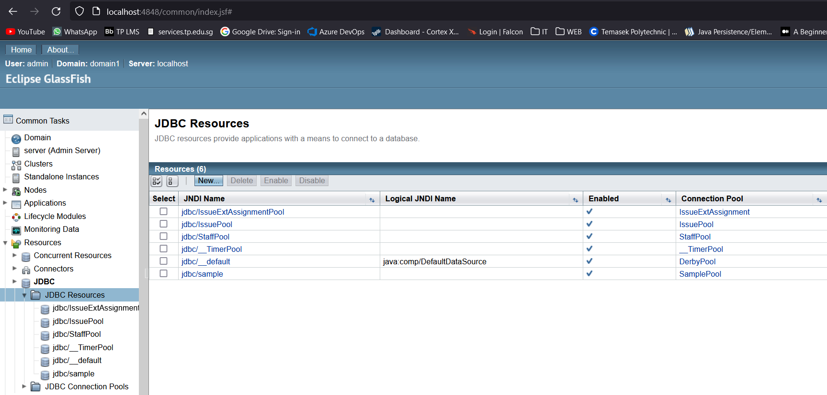
6 | Start the MySQL server
7 | Create three databases (issue, staff, issueextassignment)
8 | Open the project folders in NetBeans and make sure that it is compiled using JDK 11
9 | Right click every module: Build with Dependencies then Clean and build
10 | Run the WAR module
11 | Two of the accounts already created are:  Username: eddy@gmail.com (admin)  Password: Password0!  Username: jasmine@gmail.com (user)  Password:Password0!

Features / Capabilities

1 | Sidebar for navigating through the website
2 | Admins can register new users (Auto generated password and profile picture)
3 | Admins can view all registered users
4 | Admins can update users’ details
5 | Admins can delete users’ account
6 | Admins can view closed issues
7 | Registered users can login and logout
8 | Registered users can view their account details
9 | Registered users can only change their own password
10 | Registered users can create an issue  When creating tags for the issue, users can use default ones already created or create their own custom tags
11 | Registered users can view the details of the issue created
12 | Registered users can update the details of the issue created
13 | Registered users can archive the issue created
14 | Registered users can change the theme of the website to either light or dark after login
15 | Registered users can view the number of the respective types of issues in dashboard
16 | Search and filter for latest changes and closed issue data table
17 | Session timeout after 30 minutes
18 | Access control: Different role, different permission to Page/UI display
19 | Two-factor authentication
20 | Auto email send when a user is registered
21 | Custom made error pages: 401, 403, 404, 500

Future Enhancement

 | Feature | Additional Info
1 | Linking staff and their assistants to each issue | Use IssueExt EJB: Issue Extension EJB for assigning issue entity to other module (e.g. staff module)
2 | Adding a profile picture for registered users and admins | Auto profile picture generator already implemented.
3 | Capability of showing issues’ latest changes on the dashboard webpage | Use the issue detail timestamp to find the latest updates
4 | Users can go jump between issue versions | Issue Entity: Basic details about issue (Static)  IssueDetail Entity: Details about issue (Changeable on issue update)  Current implementation  IssueDetail has parent and child (foreign key relationship to other issue details)  Future implementation  Allow users to see the old version, current, and different branches.  Allow user to revert version and create new branch
5 | Sub issue | Create a sub issue of another issue.
6 | Message chat (Ticket system) for issue updates and client support. | Allow guest users (Customers) to communicate with MAC staff on their case.
7 | Search and filter for issue list | Tip: PrimeFaces might have a feature for this
8 | Implement security measures (e.g., input validation, defense against injection attacks) | Can refer to: https://cheatsheetseries.owasp.org/index.html

